**LAB # 03**

**SHELL PROGRAMMING**



**Spring 2024**

**CSE-204L**

**Operating System Lab**

**Submitted by: NAVEED AHMAD**

**Registration No.: 22PWCSE2165**

**Class Section: B**

“On my honor, as student of University of Engineering and Technology, I have neither given nor received unauthorized assistance on this academic work.”

Student Signature: ______________

Submitted to:

**Engr. Abdullah Hamid**

March 24, 2024.

Department of Computer Systems Engineering

University of Engineering and Technology, Peshawar

Assignment Problems on UNIX SHELL programming

1. Run all the programs given in the Lab Notes, and observe the output for each program.

Example 1

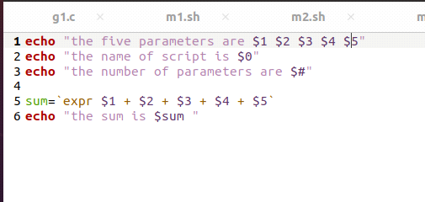

Result

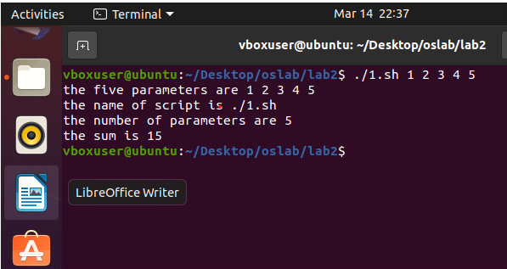

Example 2

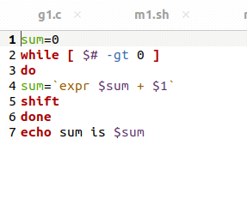

Result

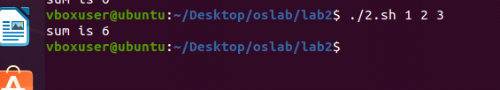

Example 3

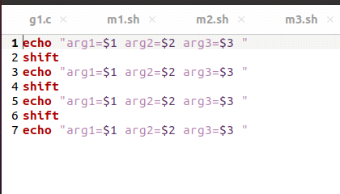

Result:

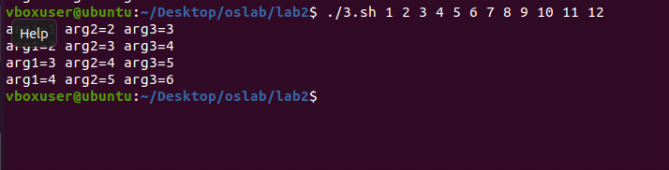

Example 4

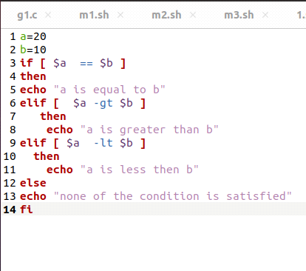

Result

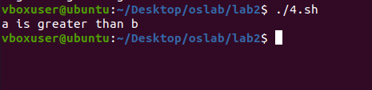

Example 5

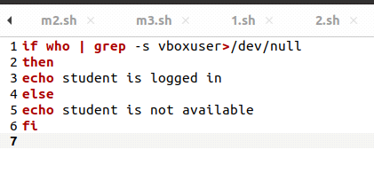

Result

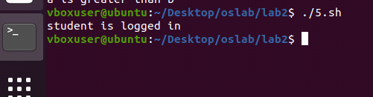

Example 6

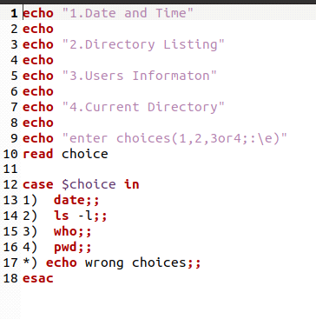

Result

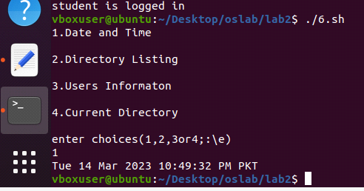

Example 7

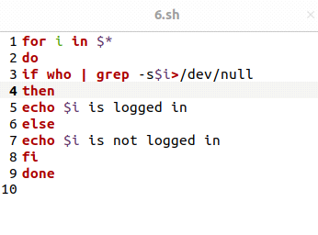

Result

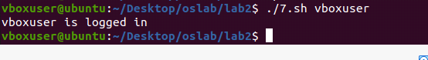

Example 9

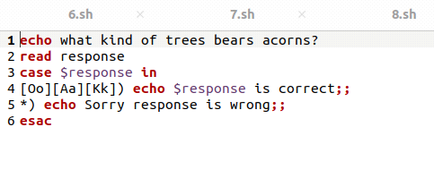

Result

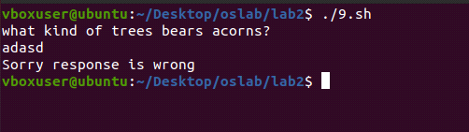

Example 10

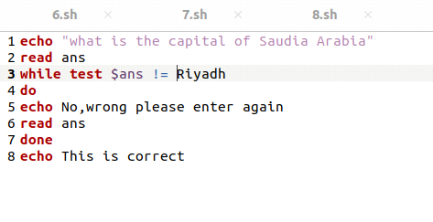

Result

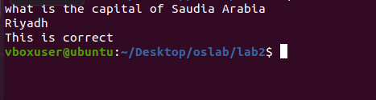

Example 11

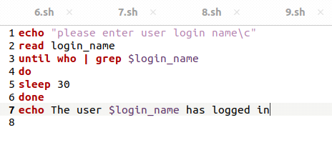

Result

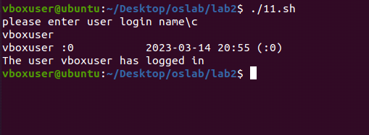

Example 12

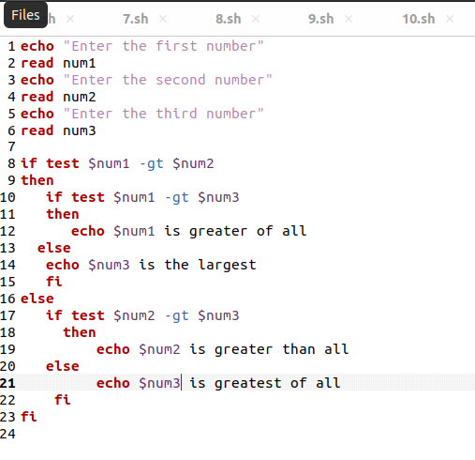

Result

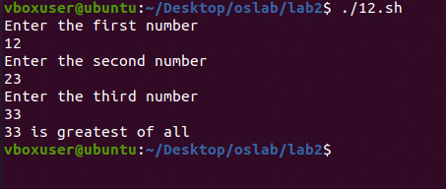

2. Write a shell script that takes a keyword as a command line argument and lists the filenames containing the keyword

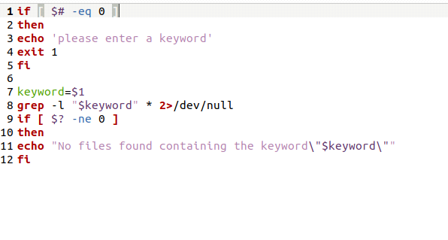

Result

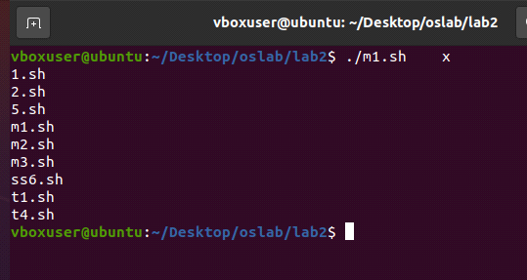

3. Write a shell script that takes a command line argument and reports whether it is a directory, or a file or a link.

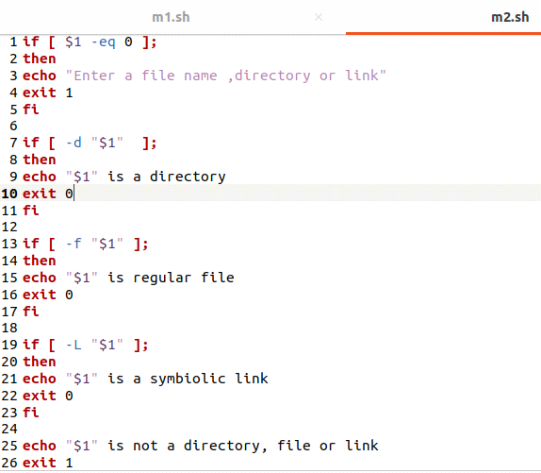

Result

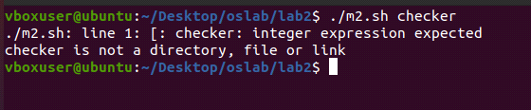

 4. Write a script to find the number of sub directories in a given directory.

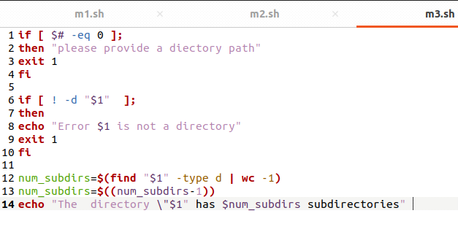

Result

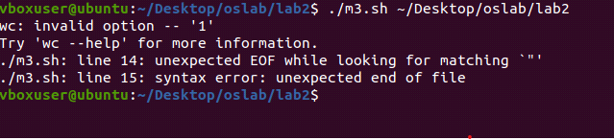

LAB ASSESSMENT RUBRICS

|  |  |  |  |  |
| --- | --- | --- | --- | --- |
| Marking  Criteria | Exceeds expectation (2.5) | Meets expectation (1.5) | Does not meet expectation  (0) | Score |
| 1. Correctness | Program compiles (no errors and no warnings).Program always works correctly and meets the specification(s). Completed between 81-100% of the requirements. | Program compiles (no errors and some warnings). Some details of the program specification are violated, program functions incorrectly for some inputs. Completed between 41- 80% of the requirements. | Program fails to or compile with lots of warnings. Program only functions correctly in very limited cases or not at all. Completed less than 40% of the requirements. |  |
| 2. Delivery | Delivered on time, and in correct | Not delivered on time, or slightly incorrect format. | Not delivered on time or not in correct format. |  |
| 3. Coding  Standards | Properindentation, whitespace, line length, wrapping, comments and  references. | Missing some of whitespace, line length, wrapping, comments or references. | Poor use of whitespace, line length, wrapping, comments and references. |  |
| 4.Presentation of document | Includes name, date, anassignment title. Task titles, objectives, output screenshots included and good formatting and excellently organized. | Includes name, date, and assignment title. Task titles, objectives, output screenshots included and good formatting. | No name, date, or assignment title included. No task titles, no objectives, no output screenshots, poor formatting. |  |

Instructor: Name: Engr. Abdullah Hamid Signature: ______________________